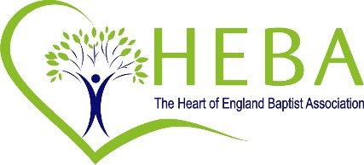

Response to Covid / Pandemic

Working with local Council in supporting those sleeping rough or in temporary accommodation
- Co-ordinating collection and distribution of food
- Weekly food parcels
- Provision of essential equipment – i.e. kettles, microwaves, etc
- Provision of clothing

Working with local Council in supporting those who are isolated
- Befriending
- Shopping
- Walking dogs
- Picking up prescriptions
- Making telephone calls to those who are at risk
- Putting out the bins, etc

Co-ordination of community conversation with statutory bodies and voluntary agencies
- Bring together 50 agencies to bring together a strategic plan post-lockdown, focused on supporting the mental health needs of young people in our community, as well as their families

Establishment of Community Support Groups and Local Care Groups

Children and YP
- Weekly on-line sessions for toddlers
- Daily and weekly activities and sessions for primary aged children
- Weekly teen groups via Zoom

Support for those isolated or alone (social distant contact – visits; phone calls)

Community activities
- Regular quiz nights
- Sunflower Growing Project (deliver seeds and instructions – create community)
- Arrange ‘at home’ camp for Brigades who should have been camping

NHS and Caring homes support
- Sewing of personal protection items (i.e. face masks, scrubs, scrub wash bags, etc)
- Vaccination Centres

Pastoral and practical support
- Help with those struggling with technology
- Shopping
- Regular contact via phone calls or WhatsApp groups
- Delivery of cards and messages of support
- Regular sharing of musical items (live outside, on-line, closed groups, etc)
- Support for those with special needs
- Support through social media for those struggling with mental health
- New Beginnings – relief project for new vulnerable mums
- Listening project – for those that want to talk
- Provision of hot cooked meals to the isolated and vulnerable
- Particular focus on the fearful, those with ill health and the vulnerable
- Support of some other local charities

Support of local Foodbanks
- Collection of food and money
- Help with distribution

Provision of support for those who have lost loved ones
- Contact and listening ear
- Funeral service (include live links)
- Regular services to help people say ‘goodbye’ and to mourn
- Good Grief Café
- ‘A time to say goodbye’ gathering

Services and sermons and Bible studies
- Weekly live or pre-recorded services on social media platforms
- Zoom gatherings
- Deliver to those without access to internet recorded messages
- Thought for the Day

Prayer times
- Daily and weekly sessions

The Baptist churches have worked well across the denominations too to provide a co-ordinated Christian response.

